Carpool
For the safety of our students and the convenience of parents, and for the peace and quiet of the neighborhood, YAYOE offers a carpool line for loading and unloading students (see below for information regarding carpool line procedures.)

It is NEVER legal, safe or permissible to load or unload children while “double parked”, i.e., standing in a traffic lane, or to do so while stopped in a red zone or blocking a driveway. Children must ALWAYS be loaded or unloaded from a legally parked car.
If you are dropping off or picking up a student outside of carpool hours, or if for any reason you will not be using the carpool line to pick up your child, you must park in a legal parking spot on the street, and escort your child or children to and from the campus. Dropping children off from street parking to walk themselves to or from school is not allowed.
In the interests of carpool safety and efficiency, please make sure that all booster seats and car seats are arranged in their proper places prior to entering the campus carpool lane. Booster seats may not be left in hallways due to fire regulations.

How to Enter and Exit the Carpool Line:

Enter through the Formosa Ave. gate, exit through the Detroit St. gate.
  - Enter Formosa Ave. by turning right from westbound Third Street. The line forms as a single-file line from the Formosa Ave. gate, with the backup wrapping around the corner when necessary into the far right lane of west-bound Third St., following the property frontage of the Yeshiva. Turning left into Formosa from eastbound Third Street during carpool hours impedes the flow of street traffic and is not allowed.

EXIT by turning right onto southbound Detroit St. Turning left (north) onto Detroit St. from the Yeshiva campus burdens our neighbors and is not allowed.
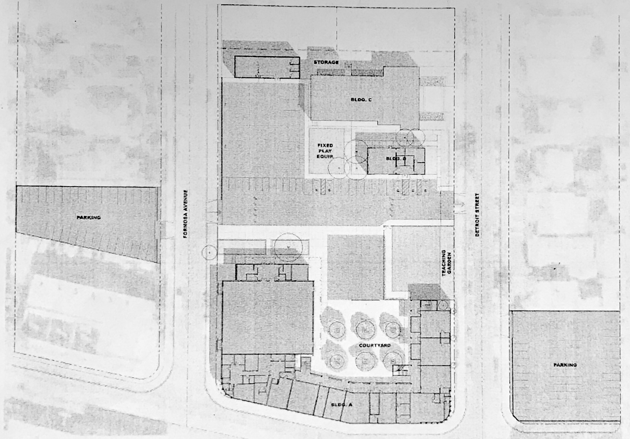
YARD ZONE E:
SOCCER FIELD
BLDG. C
AUDITORIUM
YARD ZONE C:
PLAYGROUND
A
B C D
Carpool Cars Pickup Zone (along Cones 1-8) 1 2 3 4 5 6 7 8

YARD ZONE B: PRESCHOOL
YARD
HANDBALL YARD
YARD ZONE A:
LUNCH YARD
YARD ZONE F:
3rd FLOOR PATIO
DETROIT ST. EXIT

Traffic Control Positions A-D

Student Loading Area, Cones 1-8
Carpool Car Traffic Area
BLDG. A MAIN BUILDING

GYM
Student Carpool Waiting Zone
FORMOSA ST. ENTRANCE
BLDG. D LIBRARY

Carpool Cars Traffic Zone
BLDG. B STUDIO

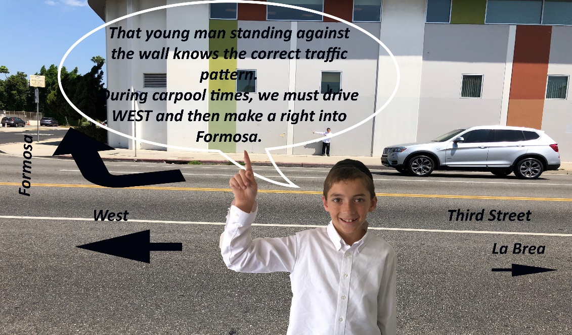
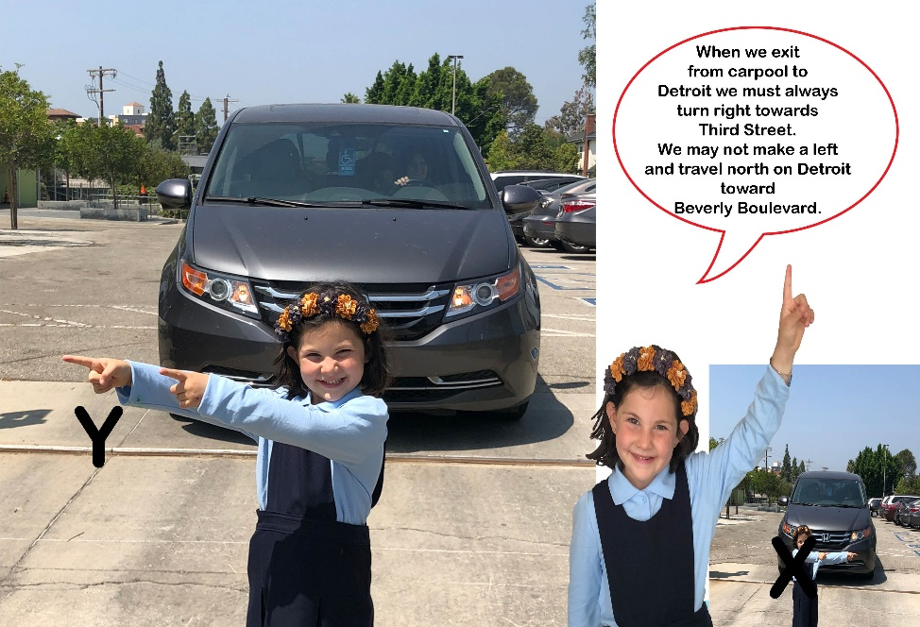
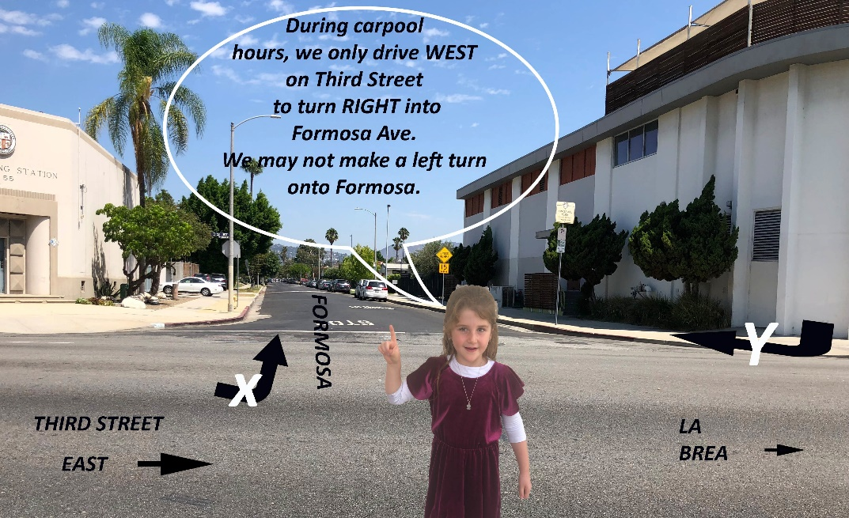
A Friendly Visual Guide to Entering and Exiting Carpool Line:

Enter Formosa Ave. by turning right from westbound Third Street.

Do not turn left into Formosa Ave.
from eastbound

Third Street!

EXIT by turning right onto southbound Detroit St.

Carpool Procedures & Rules:
  - Follow instructions of carpool team.

Carpool is a cellphone-free zone.
Using your cell phone for talking or texting while at the wheel on campus poses a very real danger to students and is not permitted.
  - Once in the carpool lane, pull forward as far as is safe, allowing cars behind you to get into the drop-off/pick-up zone.
  - Use extreme caution while proceeding through the carpool line, as small children may be loading in front of and/or behind your vehicle.
  - After stopping, put your car in Park. Cars may drift while standing, or move after the door has been opened.
  - Do not leave your vehicle during carpool. Allow a faculty member to open the car door and assist your children in and out of the car.

Children may not enter or exit a vehicle from the left side of the car.
  - Remember that only the lead car pulls out.

DO NOT PULL OUT AROUND THE CAR IN FRONT OF YOU.
This may take an extra minute, but it is the safest procedure to follow. Use your turn signal when leaving the drop-off zone.
  - Be alert to the active crosswalks near both the Detroit St. AND the Formosa Ave. gates.
  - EXIT to the right onto southbound Detroit St. Turning left (north) onto Detroit St. from the Yeshiva campus burdens our neighbors and is not allowed.

Non-Carpool

Student Transport:

Walking, Biking and Scootering to School
Children who walk or ride bikes or scooters to school must have signed parental permission forms on file in the office. (Permission forms may be obtained from the front office and the completed forms returned to the office BEFORE the student comes to school on their own).
Students must wear helmets while riding a bicycle or scooter, and must dismount before walking their scooters/bikes through the pedestrian gates onto campus. Riding bicycles or scooters on campus is not allowed at any time, for the safety of other students.
Skateboards, rollerblades, and motorized scooters are not allowed on campus.

Children on Campus Before & After School Hours
YAYOE is please to offer many optional after-school activities on campus, including enrichment classes.
While on-campus with your children, you must supervise them! Please stay in close proximity to children, watching them at all times while they are playing.

Eyes on your cellphone does not count as watching your children.

